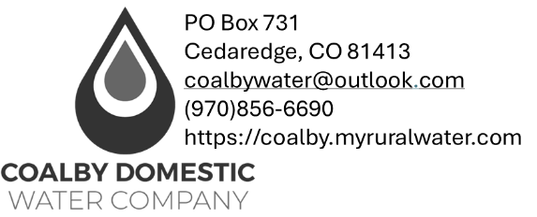

Transfer of Water Tap/Membership cost is $50/tap paid by the Buyer
Account Information
Closing Date | Click or tap here to enter text.
Service Address | Click or tap here to enter text.
Parcel Number | Click or tap here to enter text.
Subdivision | Click or tap here to enter text.
Seller Information
Seller Name | Click or tap here to enter text.
Seller Email | Click or tap here to enter text.
Seller Phone # | Click or tap here to enter text.
Seller Forwarding Address
Seller Forwarding Street Address | Click or tap here to enter text.
Seller Forwarding City/Town | Click or tap here to enter text.
Seller Forwarding State & ZIP | Click or tap here to enter text.
Buyer Information
Buyer Name | Click or tap here to enter text.
Buyer Email | Click or tap here to enter text.
Buyer Phone # | Click or tap here to enter text.
Buyer Mailing Address | Click or tap here to enter text.
Buyer Street Address | Click or tap here to enter text.
Buyer City/Town | Click or tap here to enter text.
Buyer State State & ZIP | Click or tap here to enter text.
If buyer information is unknown, please use Title Company information as a placeholder and email coalbywater@gmail.com with updated buyer information as soon as possible.
Title Company Information
Title Company | Click or tap here to enter text.
Title Company File # | Click or tap here to enter text.
Title Mailing Address | Click or tap here to enter text.
Title Street Address | Click or tap here to enter text.
Title City/Town | Click or tap here to enter text.
Title State & ZIP- | Click or tap here to enter text.
Title Phone # | Click or tap here to enter text.
Closer | Click or tap here to enter text.
Agent Name | Click or tap here to enter text.
Agent Email | Click or tap here to enter text.

Water Tap Transfer Fee $50/tap, payable at closing.
New Member Name:
1 | 20251 Green Valley Rd, Cedaredge, CO 81413 | $50
2 | 20251 Green Valley Rd Cedaredge, CO 81413 | $50

